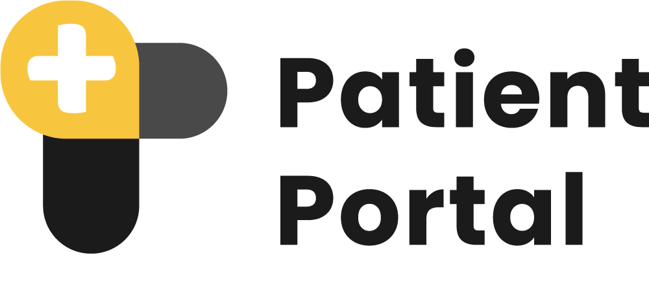
Share and access medical imaging data securely.

Application Landscape for Patient Imaging Portal


A Product of
Version 1.0
Document Control
Release No. | Date | Purpose/Change | Author
V 1.0 | Aug 21, 2024 | Initial Release | S M Al Shahaneaz Shaikat

Table of Contents
1. Business Purpose and Data Confidentiality 4
1.1. Data Confidentiality 4
1.2. The confidentiality measures include: 4
2. On-premise BOM(Bill of Materials) 5
3. User Level Access/Rights with Privileges Mapping 5
4. Architecture and diagram 7
4.1. Mray Upload DICOM and Send Information via API 7
4.2. Patient Portal Site Registration and API Secret Key Generation 8
4.3. Patient Portal Generate New Patients & Orders 8
4.4. Display the Study in the Worklist 9
4.5. API Access for Receiving Mray Link 9
4.6. Logging and Auditing 10
5. Application Landscape 11
5.1. Hospital Admin Workflow 11
Login to the Patient Portal 11
New Site registration 11
Patient Portal Whiteboard 12
Patient Portal case on the whiteboard 12
Shareable link or QR code generator buttons on the whiteboard 13
Count of how many times a link or QR Code has been generated 13
5.2. Settings Options 13
Organization Setup 13
Update organization information 14
General information 15
API Settings page 15
Workflow settings(MRay settings) 16
User List of Patient Portal 16
Adding new Users 17
Exam Information Page 18
Adding New Exam 19
Update Existing Exam 19
6. Technical Documentation 20

1. Business Purpose and Data Confidentiality
The primary business purpose of the Patient Portal is to facilitate seamless, secure, and confidential interactions between healthcare providers and patients. It is a platform for managing patient data, generating study orders, and sharing medical images through secure, shareable links or QR codes.

1.1. Data Confidentiality

The Patient Portal's critical focus is data confidentiality. The system uses industry-standard protocols to ensure that all patient records, DICOM files, and communications are securely stored and transmitted. This approach mitigates the risk of unauthorized access and complies with HIPAA (Health Insurance Portability and Accountability Act) and GDPR (General Data Protection Regulation).

1.2. The confidentiality measures include:

- Role-based access control (RBAC) to limit data access to authorized personnel
- Safety logic guarantees that only patients can view their images and reports.
- Secure API integrations for data exchange

2. On-premise BOM(Bill of Materials)
To successfully deploy and run the Patient Portal, the following hardware components are required:
- Server-Side Requirements
  - On-Premise Server: on-premise server with a minimum of 32GB RAM, 1TB SSD storage, and quad-core processors for optimized performance.
  - Dedicated Database Server(Recommended): A separate database server running Postgresql with a minimum of 32GB RAM and 1TB SSD storage for scalable data handling is highly recommended.
  - Dedicated Backup Storage(Recommended): To ensure secure, regular backups of patient data and study records, an external or cloud-based backup solution with at least 2TB storage is recommended.

3. User Level Access/Rights with Privileges Mapping
The Patient Portal implements a Role-Based Access Control (RBAC) system that defines specific access levels based on the user’s organizational role. Below is a high-level outline of user access levels and their respective privileges:

User Role | Access Level | Privileges
Super Admin | Full Access | - All site access  - Site signup approval  - Create a new site  - View all site information
Site Admin | Single Site Full Access | - Manage a single site settings and configurations  - Access to all patient records, studies, and user activity logs  - Grant/revoke permissions for other users
API User | API Request | - Order Create  - Link Request

4. Architecture and diagram
The following application landscape outlines the interaction and data flow between various components within the Patient Portal system, incorporating the exchange of DICOM data, patient information, and API integrations. This landscape enables a seamless workflow from initiating a study in Mray to managing and distributing medical data in the Patient Portal.
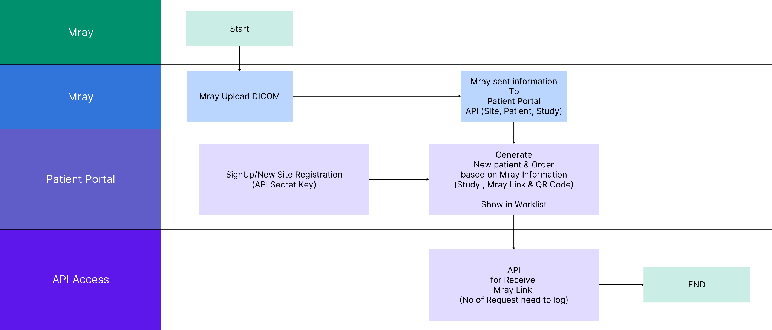

4.1. Mray Upload DICOM and Send Information via API
- Objective: Initiate the collection of patient data, study information, and DICOM files.
- Upload DICOM files and use the API to transmit site, patient, and study information to the Patient Portal.
- Actions:
  - Begin by collecting patient demographics and study details.
  - Prepare DICOM images for upload.
  - Upload DICOM images to Mray's server.
  - Send an API request to the Patient Portal, including:
    - Site Information: Clinic or hospital identification
    - Patient Information: Name, age, medical history
    - Study Information: Modality, study details, physician name
Outcome: DICOM files and related information are securely sent to the Patient Portal.

4.2. Patient Portal Site Registration and API Secret Key Generation
- Objective: Register new sites and generate API Secret Keys for secure data exchange.
- Actions:
  - Site administrators complete the sign-up process in the Patient Portal.
  - The Patient Portal generates a unique API Secret Key for each new site.
  - The key is provided to the site for future interactions with the Patient Portal.
Outcome: New sites are registered, and secure API keys are generated for data transmission.

4.3. Patient Portal Generate New Patients & Orders
- Objective: Automatically generate new patient profiles and study orders based on information received from Mray.
- Actions:
  - The Patient Portal creates new patient profiles using the information provided by Mray.
  - A new order is generated, detailing the study and linking it to the patient profile.
  - The system generates a unique Mray Link and QR Code associated with the study.
Outcome: New patients and orders are created and linked to their respective studies. A Mray Link and QR Code are generated.

4.4. Display the Study in the Worklist
- Objective: Display the newly created patient profile, study details, and Mray Link/QR Code in the Patient Portal's worklist.
- Actions:
  - The system displays the new patient and study order in the worklist.
  - The associated Mray Link and QR Code are available for quick access and sharing.
Outcome: The patient’s study is visible in the worklist, with the Mray Link and QR Code available.

4.5. API Access for Receiving Mray Link
- Objective: Allow external systems and authorized users to access the Mray Link and study information via the API.
- Actions:
  - External systems request the Mray Link via the Patient Portal's API.
  - The API provides access to the Mray Link and QR Code.
  - Every access request is logged, including the number of times the study link has been shared or accessed.
Outcome: Authorized users can retrieve and share study links securely. All interactions are logged for auditing purposes.

4.6. Logging and Auditing
- Objective: Track all interactions with study links to ensure compliance and security.
- Actions:
  - Log the number of requests for Mray Links.
  - Record user activity, including timestamps and actions related to the access and sharing of study data.
Outcome: All interactions with study links are logged, and audit trails are maintained for security and regulatory compliance.

5. Application Landscape

5.1. Hospital Admin Workflow

Login to the Patient Portal
Access the portal by visiting https://myimagingportal.com
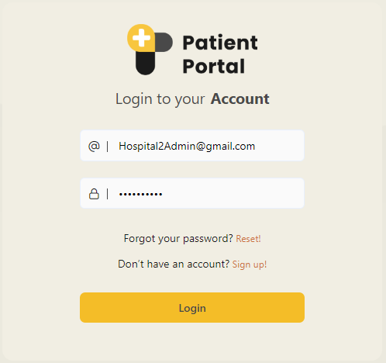

New Site registration
To register for a new site, click the Sign Up! button, which will take you to the signup page.
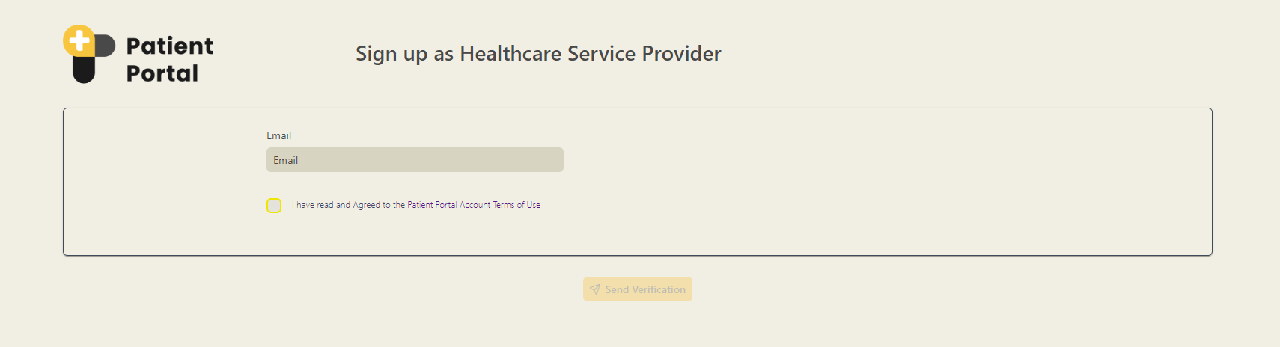

Patient Portal Whiteboard
After logging in, you should see the Patient Portal whiteboard.
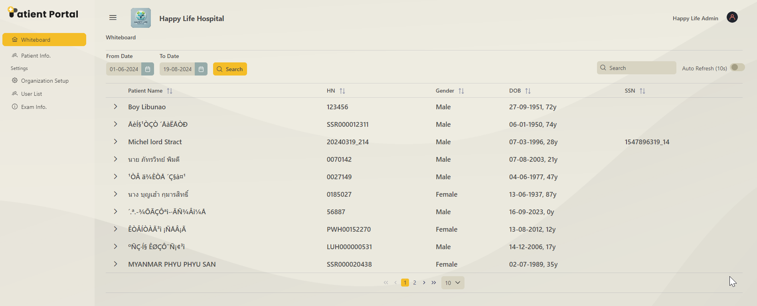

Patient Portal case on the whiteboard
Clicking on the arrow button lets you review a case in detail.
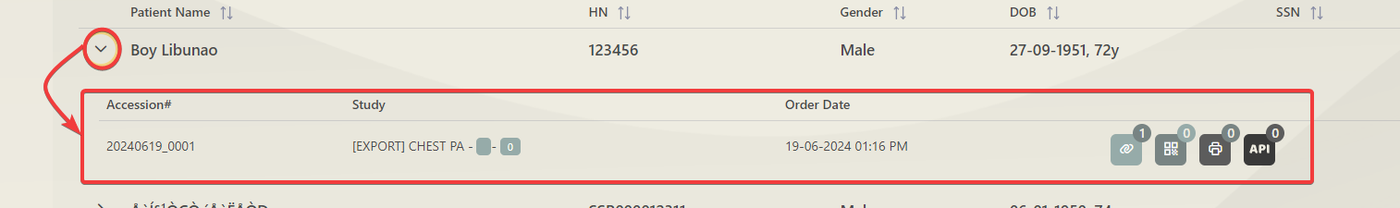

Shareable link or QR code generator buttons on the whiteboard
In the dropdown, the shareable buttons are accessible
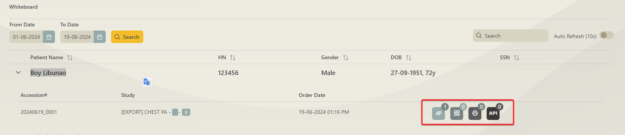

Count of how many times a link or QR Code has been generated
A shareable link and QR code can be generated from here. You can also print the QR code from here. Here, you can see the number of times a link has been clicked.
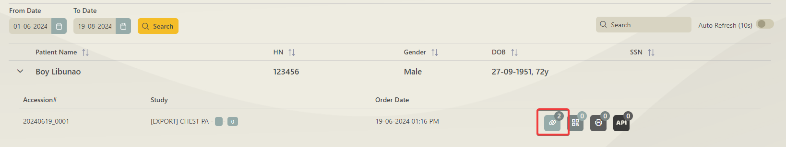

5.2. Settings Options

Organization Setup
This page displays all the existing organizations. You can also update organization information on this page.
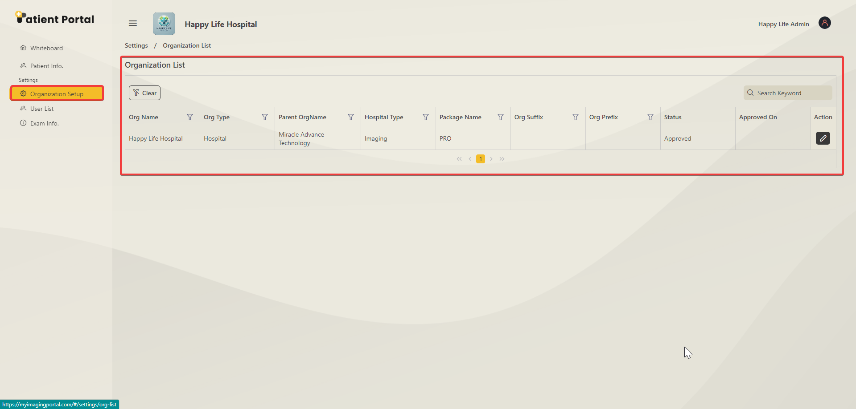

Update organization information
When the update button is clicked, a popup page appears, and you can update the general information, API settings, and workflow here.

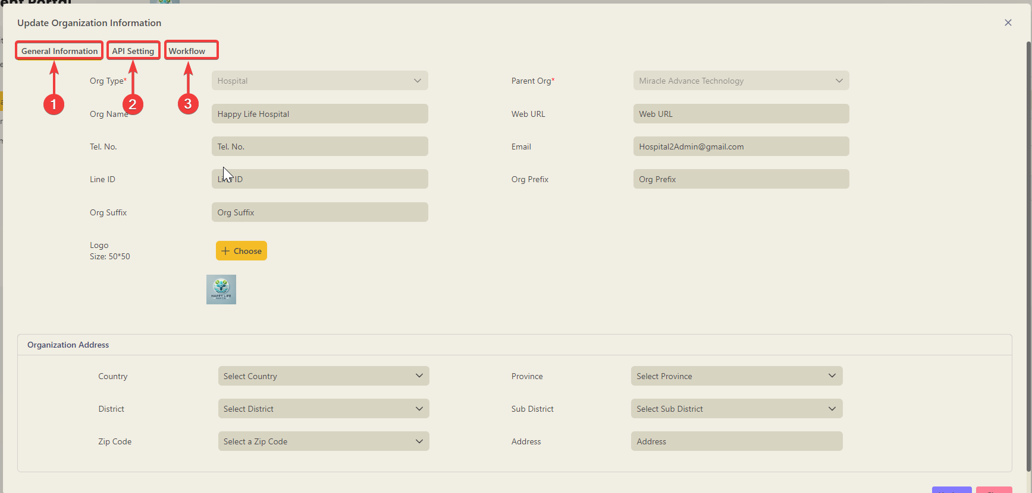

General information
The general information page lets you update the Information and address of the organization.
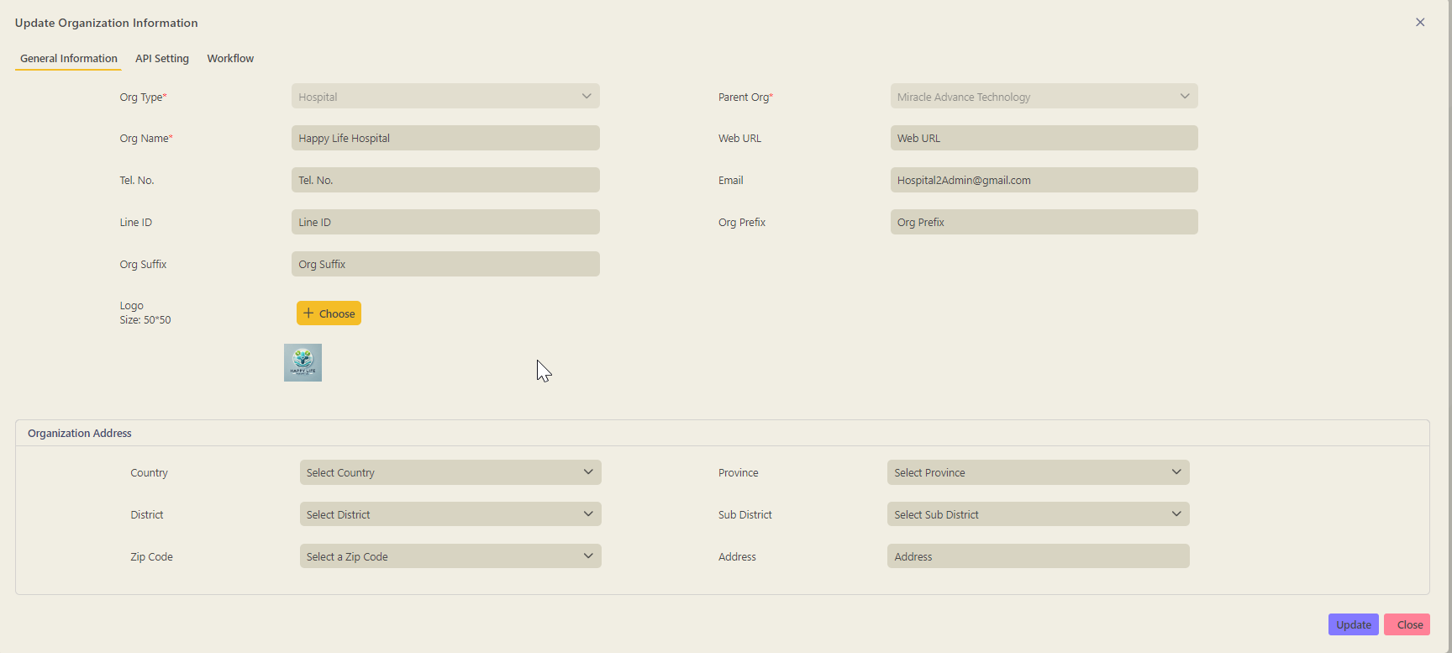

API Settings page
All incoming and outgoing APIs for a specific organization can be updated here.
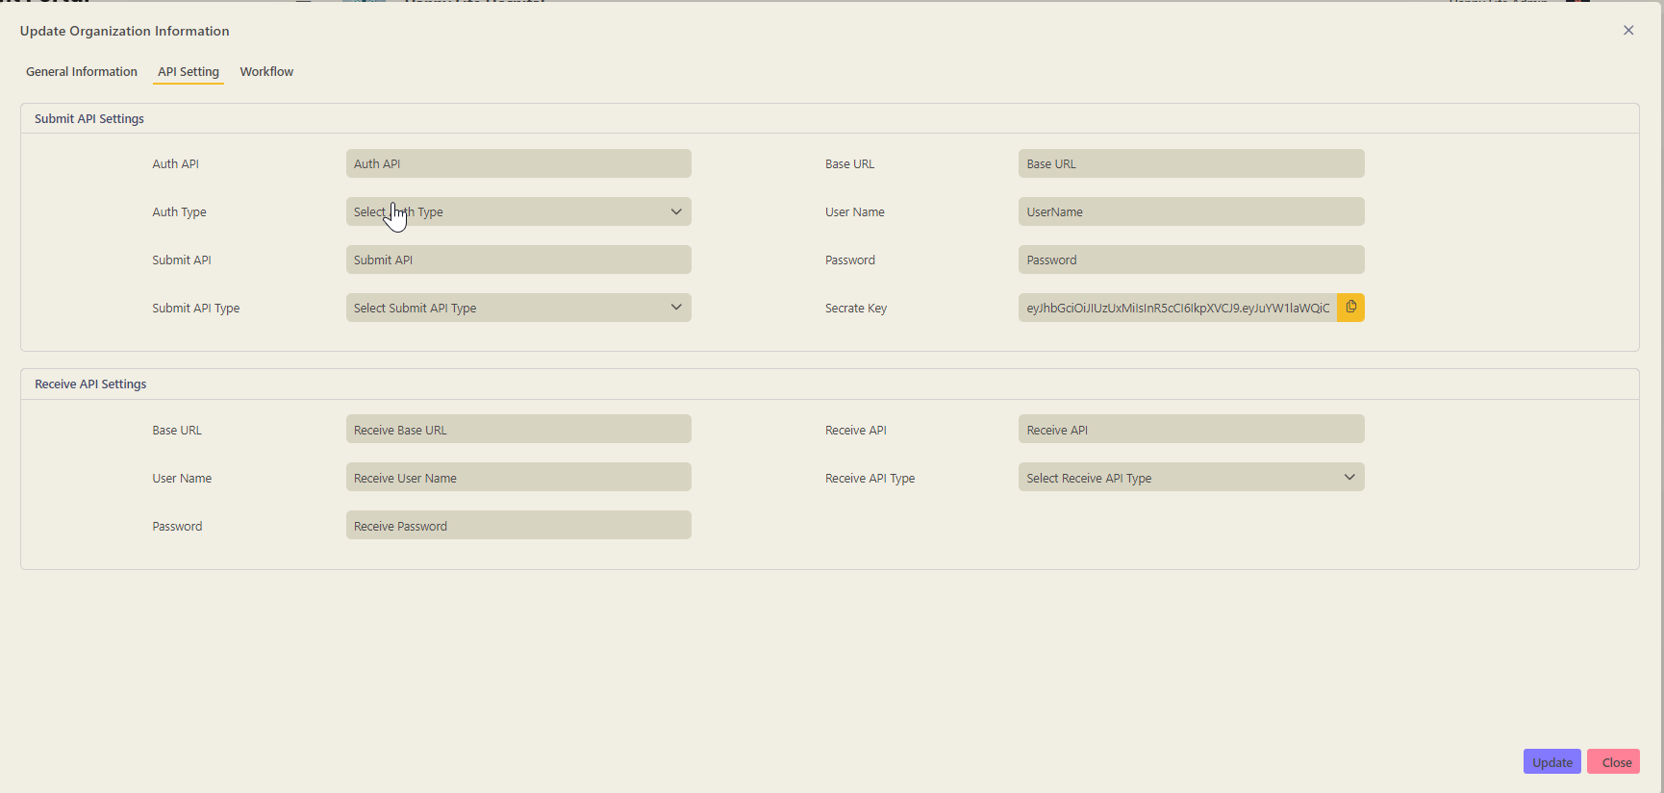

Workflow settings(MRay settings)
All the MRay settings can be added or updated from this page.
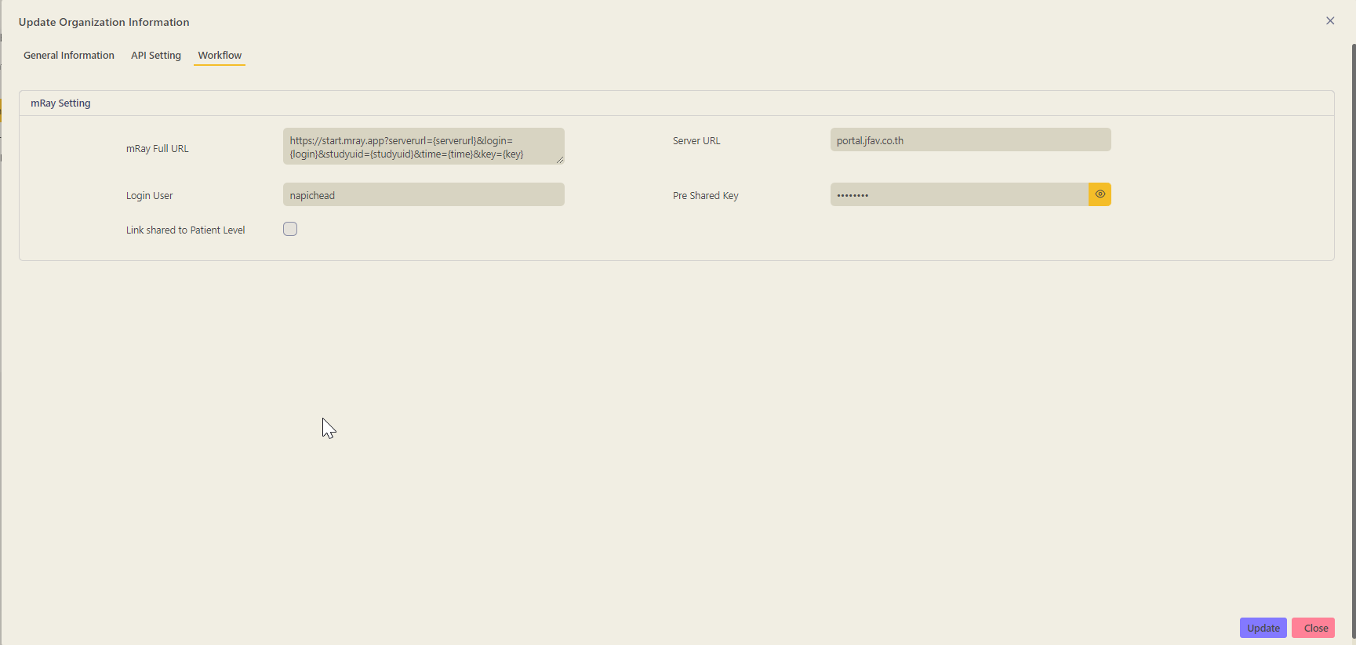

User List of Patient Portal
All the users or roles can be reviewed, added, removed, or updated on this page.

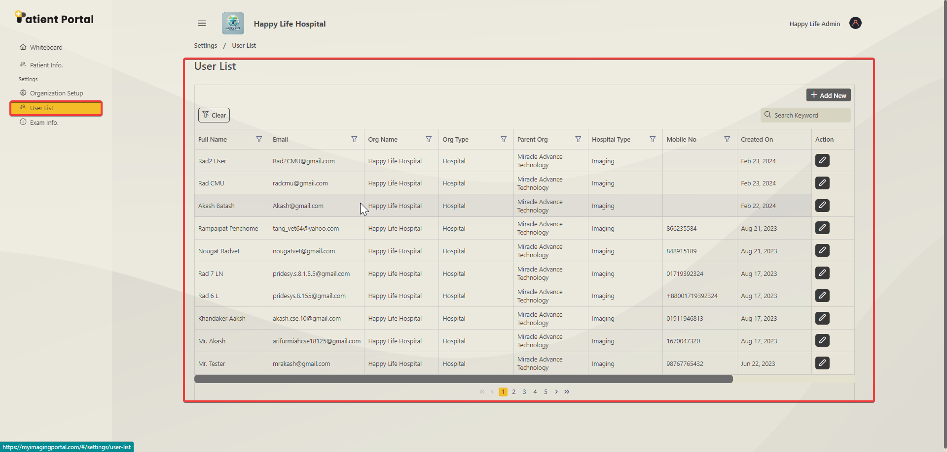

Adding new Users
A new user is added by clicking on the Add New button.
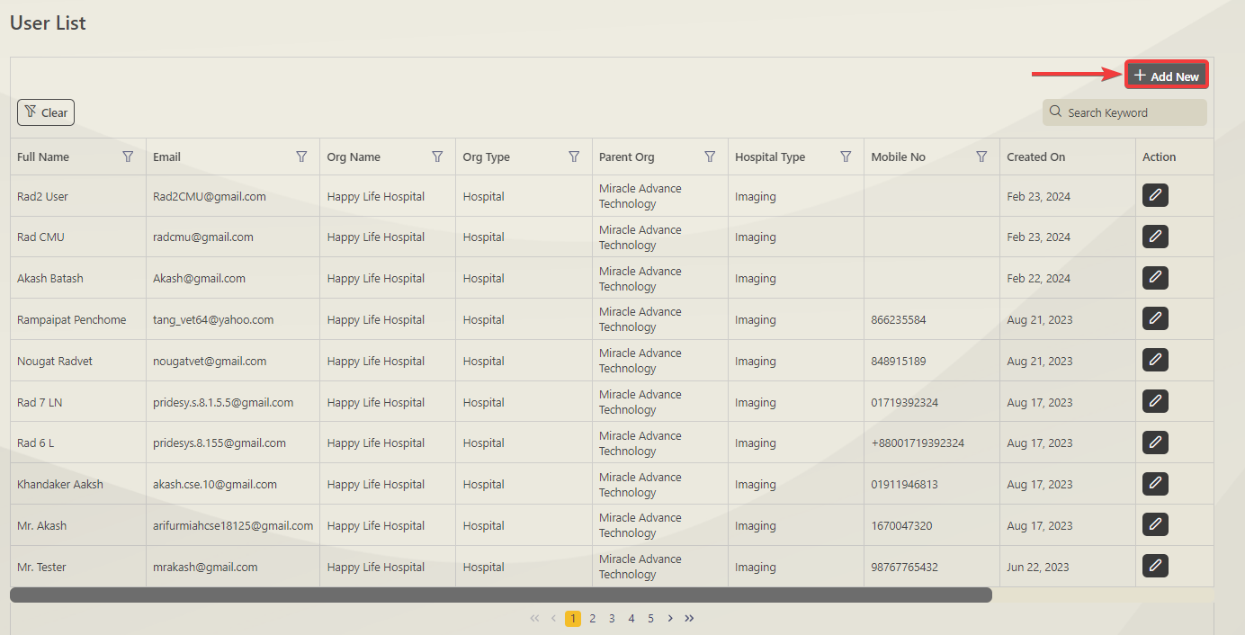

After clicking, an add new user page pops up. Before submitting the form, you must fill in all the information marked with a Red Asterisk(*).

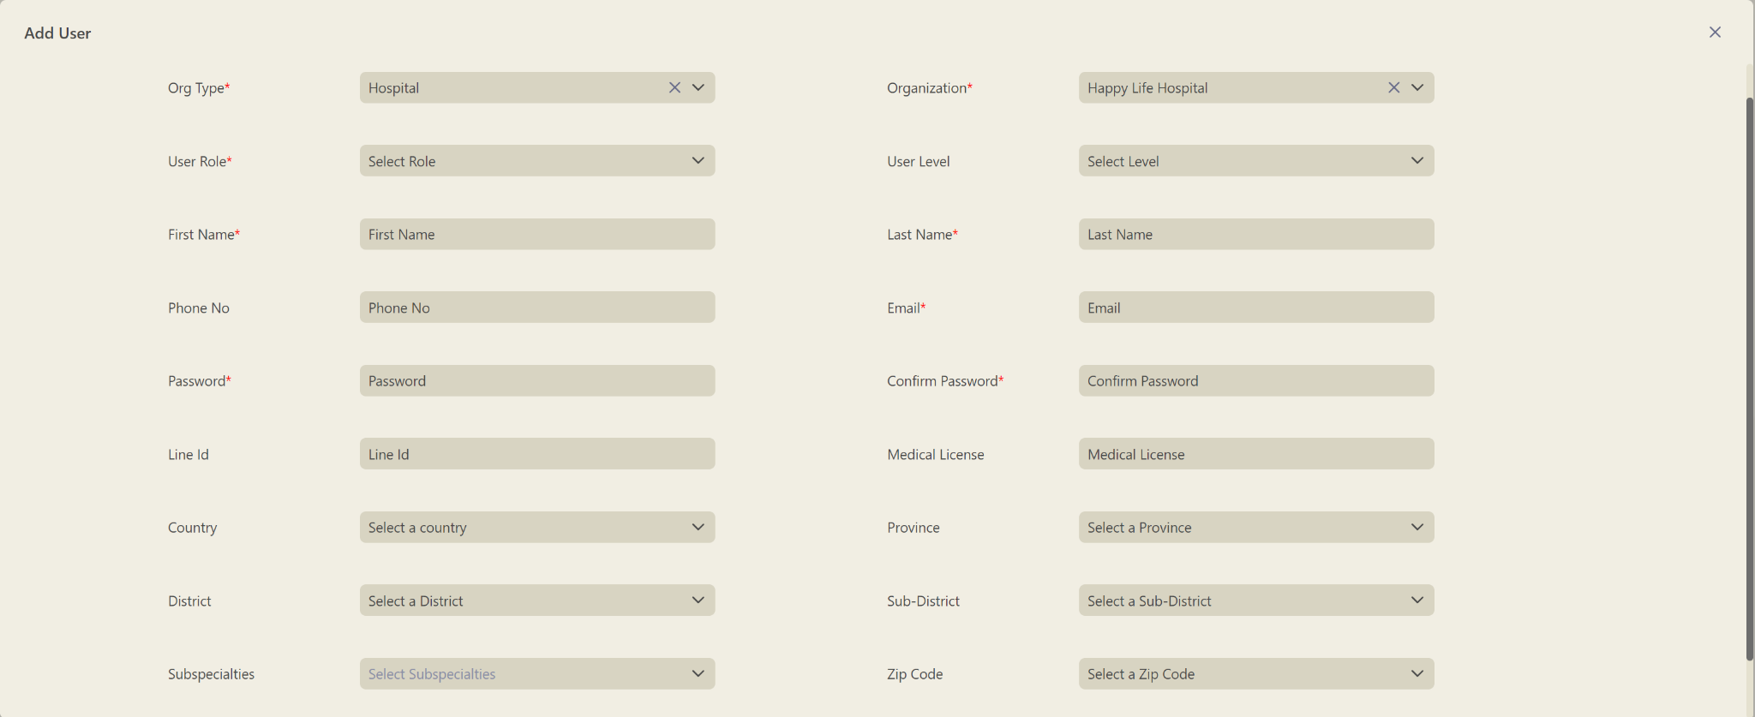

Update Existing Users
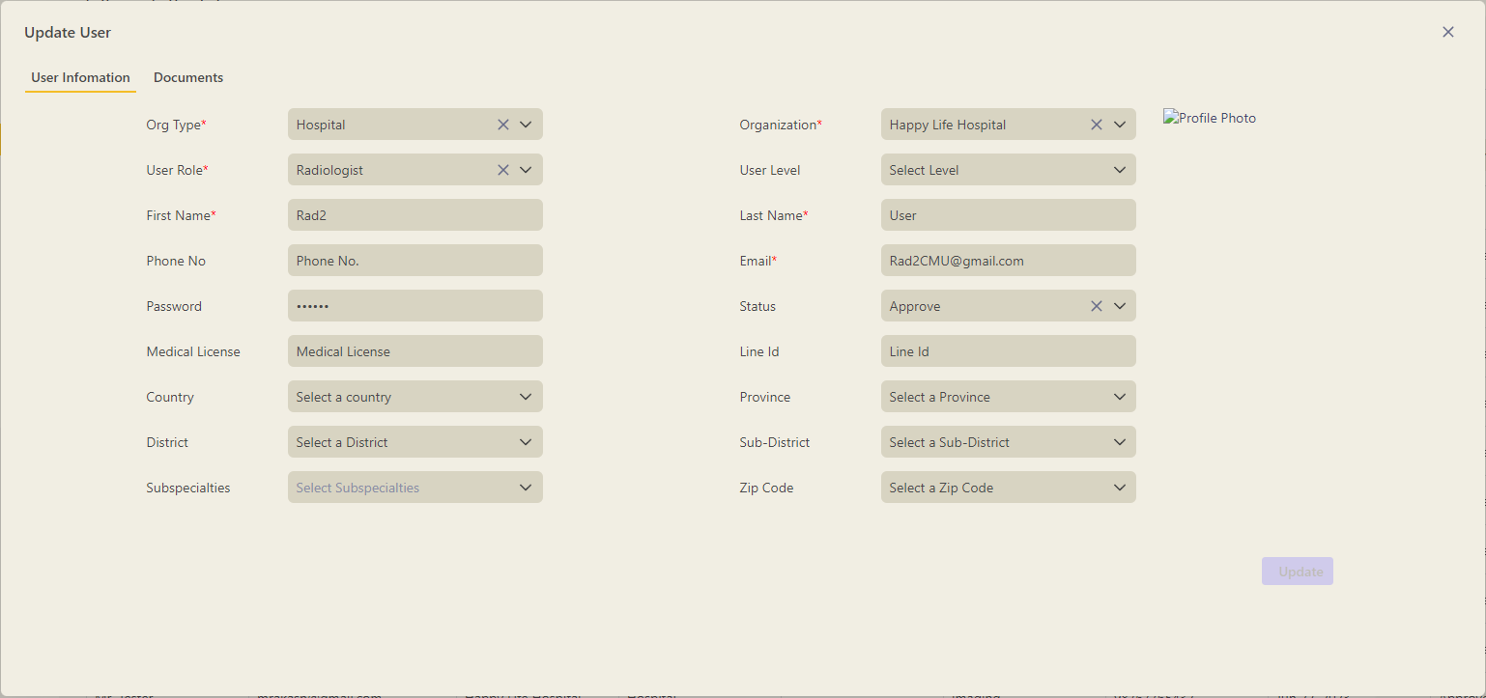

Exam Information Page
All the exams can be mapped and configured on the Exam information page.

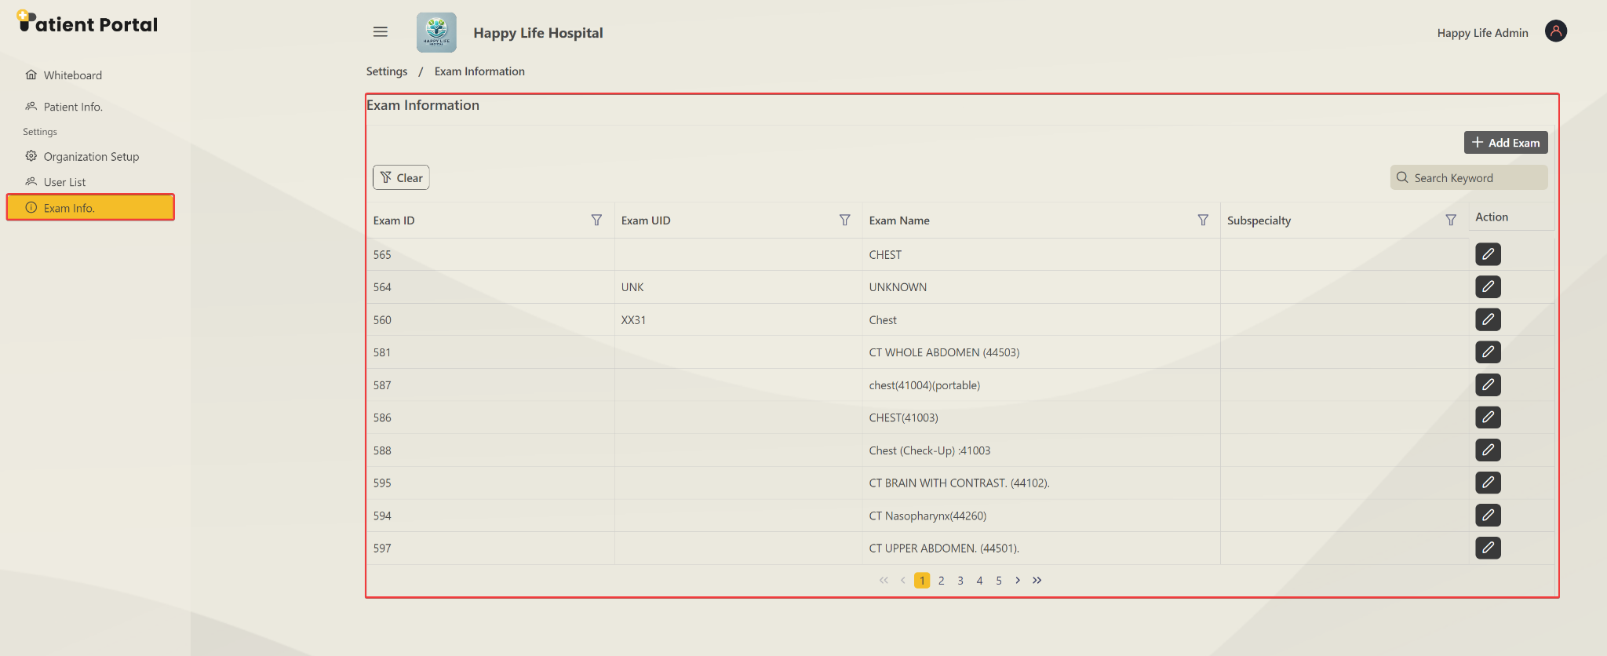

Adding New Exam
A new exam can be added. After clicking the Add Exam button, you should see a popup window where you can add the name UID and Subspecialty for the new exam.

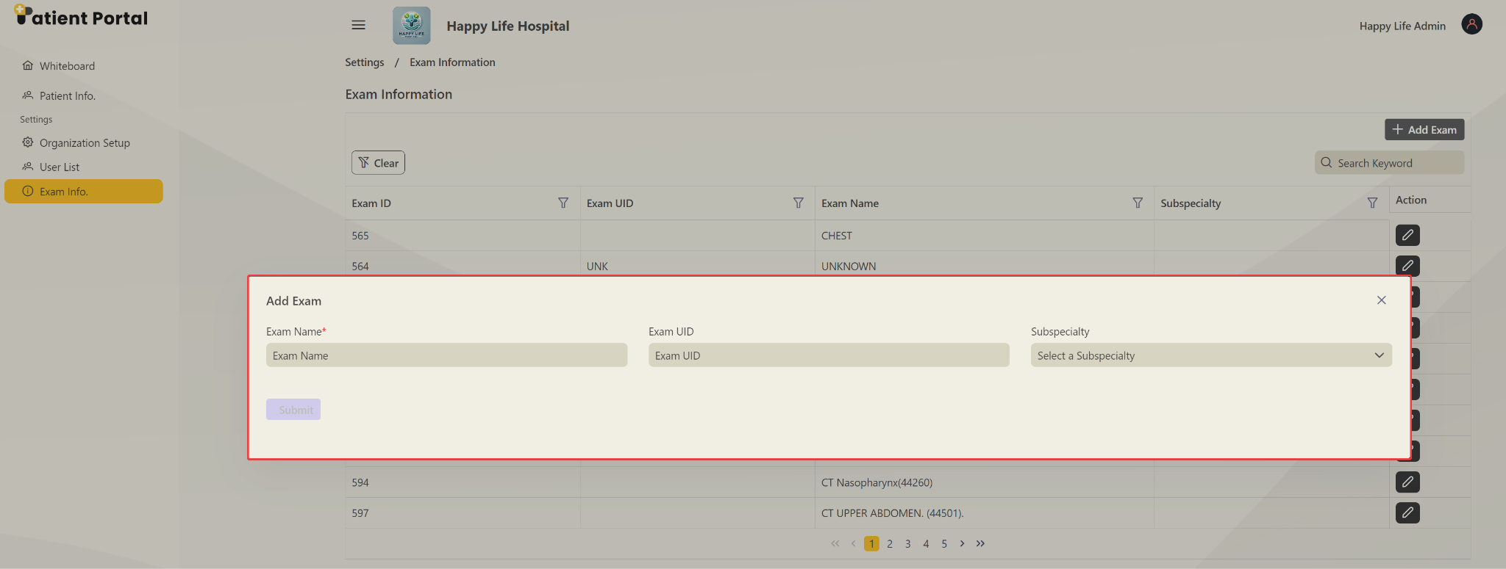

Update Existing Exam
The exam can be updated by clicking on the edit button.

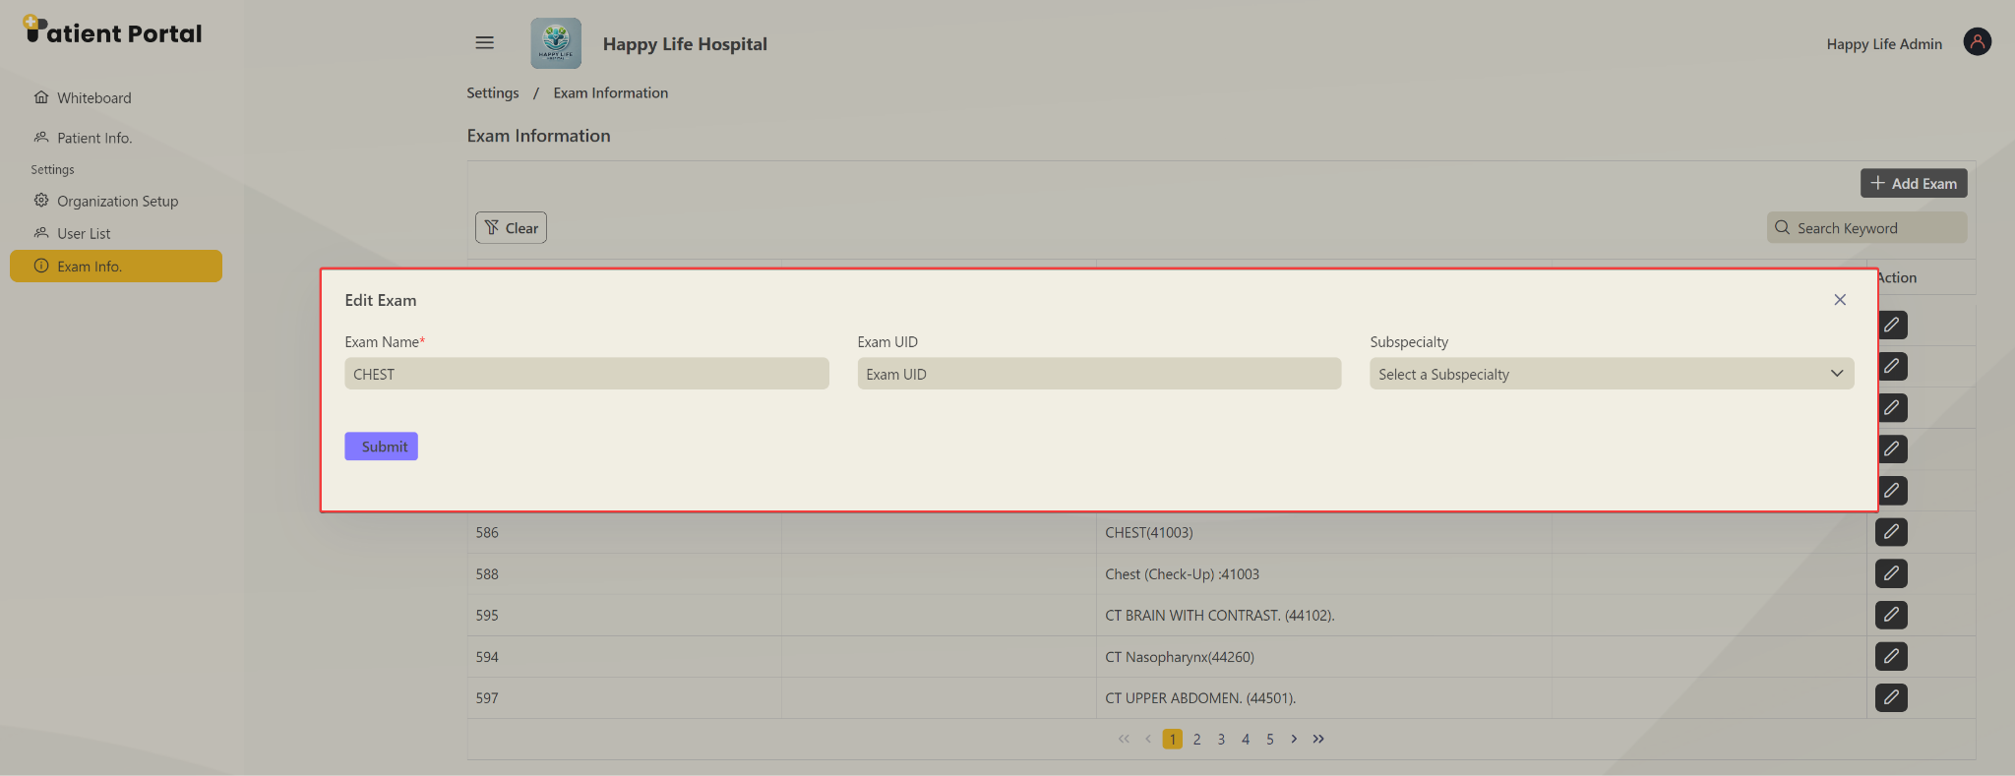

6. Technical Documentation
Please refer to the document for API documentation on creating imaging orders and sharing links and QR codes - Patient Portal API Documentation

